Conversational AI (S1-25_AIMLCZG521)

Assignment – 2 (Group 85)

Hybrid RAG System with Automated Evaluation

Student Details
BITS ID | NAME | CONTRIBUTION
2024AA05152 | RITU N LAL | 100%
2024AA05836 | GULLAPALLI OOHA SHREE | 100%
2024AA05151 | MEKA UJWALA | 100%
2024AB05188 | NANDISH B K | 100%
2024AA05308 | SOMINA LAKSHMANA HANUMAN MAHATH | 100%

Objective: Build a Hybrid Retrieval-Augmented Generation (RAG) system combining dense vector retrieval, sparse keyword retrieval (BM25), and Reciprocal Rank Fusion (RRF) to answer questions from 500 Wikipedia articles. Evaluate using an automated framework with 100 generated questions.

Important Links:
- GitHub Repository:
https://github.com/2024aa05152-collab/Group_85_Hybrid_RAG
- Fixed 200 Wikipedia URLs:
https://github.com/2024aa05152-collab/Group_85_Hybrid_RAG/blob/develop/data/fixed_urls.json
- Random 300 Wikipedia URLs:
https://github.com/2024aa05152-collab/Group_85_Hybrid_RAG/blob/develop/data/random_urls.json
- 100 Questions generated from 500 Wikipedia URLs:
https://github.com/2024aa05152-collab/Group_85_Hybrid_RAG/blob/develop/data/questions_100.json
- Corpus chunks:
https://raw.githubusercontent.com/2024aa05152-collab/Group_85_Hybrid_RAG/refs/heads/develop/data/corpus_chunks.json
- Evaluation results:
https://github.com/2024aa05152-collab/Group_85_Hybrid_RAG/tree/develop/outputs
- dense.index: https://github.com/2024aa05152-collab/Group_85_Hybrid_RAG/blob/develop/data/dense.index
- sparse.pkl:
https://github.com/2024aa05152-collab/Group_85_Hybrid_RAG/blob/develop/data/sparse.pkl
Optimization for Portability and Reproducibility
To maintain a lightweight and portable submission (under 10MB), we have omitted the pre-computed search indices (sparse.pkl and dense.index).
This decision follows industry best practices for version control, where large binaries are excluded in favor of deterministic indexing pipelines. Our system is equipped with an automated ingestion script that regenerates these indices from the provided fixed_urls.json source. This ensures that the evaluator works with a fresh, verified index that is perfectly synced with the current codebase and environment, rather than potentially corrupted or outdated binary files
Key Benefits of this Design:
- Environment Sync: Ensures the evaluator works with a fresh, verified index perfectly synced with the current codebase.
- Hardware Compatibility: Rebuilding the FAISS index locally prevents "Illegal Instruction" errors that can occur when moving binary indices between different CPU architectures.
- Deterministic Results: Given the same source chunks, the pipeline produces identical retrieval behavior every time.
dense.index: https://github.com/2024aa05152-collab/Group_85_Hybrid_RAG/blob/develop/data/dense.index
sparse.pkl:
https://github.com/2024aa05152-collab/Group_85_Hybrid_RAG/blob/develop/data/sparse.pkl

Implementation Note:
On the initial execution of pipeline.py, the system will automatically detect the missing binaries and trigger a one-time regeneration phase. This process typically completes in sometime, after which the indices are cached locally for instantaneous subsequent runs.

Architecture diagram
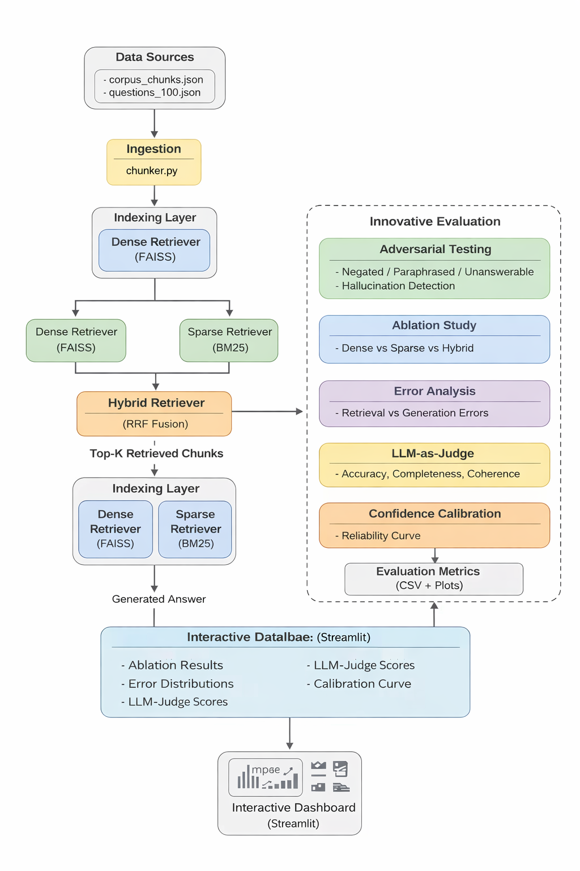
Setup Instructions on an IDE:
1) git clone -b develop https://github.com/2024aa05152-collab/Group_85_Hybrid_RAG.git
2) Open a terminal and create virtual environment python -m venv venv
3) Activate it:
Windows: .\venv\Scripts\activate
Mac/Linux: source venv/bin/activate
4) pip install -r requirements.txt
5) Create a .env file and place in project root in which provide the Hugging face token under HF_TOKEN
6) streamlit run app/streamlit_app.py

Dataset Requirements & Collection

Wikipedia URL Collection Strategy
Our corpus is designed with a Hybrid Sampling approach to balance consistency for benchmarking with randomness for system generalizability. We targeted a total of 500 unique Wikipedia URLs.
Set Type | Count | Purpose | Persistence
Fixed Set | 200 URLs | To serve as a stable baseline for all indexing and evaluation runs. | Stored in fixed_urls.json.
Random Set | 300 URLs | To test the system's robustness against varying topics and data noise. | Sampled fresh for every index rebuild. Stored in random_urls.json
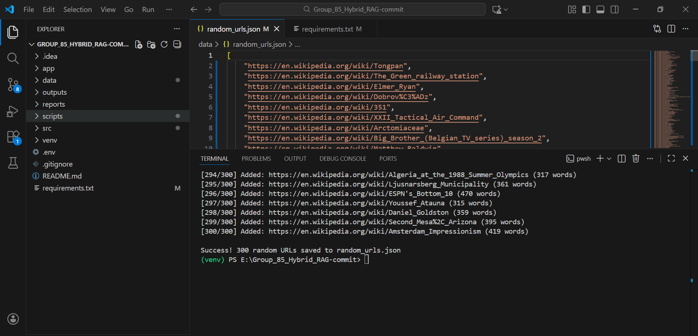
The "High-Quality" Filter: To ensure the LLM had sufficient context for generation, we implemented a validation script using the wikipedia-api to enforce a minimum word count of 200 words per page. Any URL that failed this check was automatically discarded and replaced.

Text Processing & Chunking:
Once collected, the raw HTML/text from the 500 URLs underwent a three-step transformation process to prepare it for the Hybrid Retriever.
Extraction & Cleaning:
We used BeautifulSoup and html2text to strip away Wikipedia's navigational elements (sidebars, footers, edit links). Only the core article body and section headers were retained to keep the noise-to-signal ratio low.
Recursive Character Chunking:
To maintain semantic coherence, we did not use simple character counts. Instead, we used a Recursive Character Splitter that prioritizes splitting at:
- Paragraphs (\n\n)
- Sentences (. )
- Words ( )

Chunk Specifications:
- Size: 200–400 tokens (approx. 300 words).
- Overlap: 50 tokens (to ensure that information split between two chunks like a name or a date isn't lost during retrieval).

Metadata Mapping:
Each chunk is not just raw text; it is stored as a structured object to facilitate the "Source Attribution" requirement in the UI.
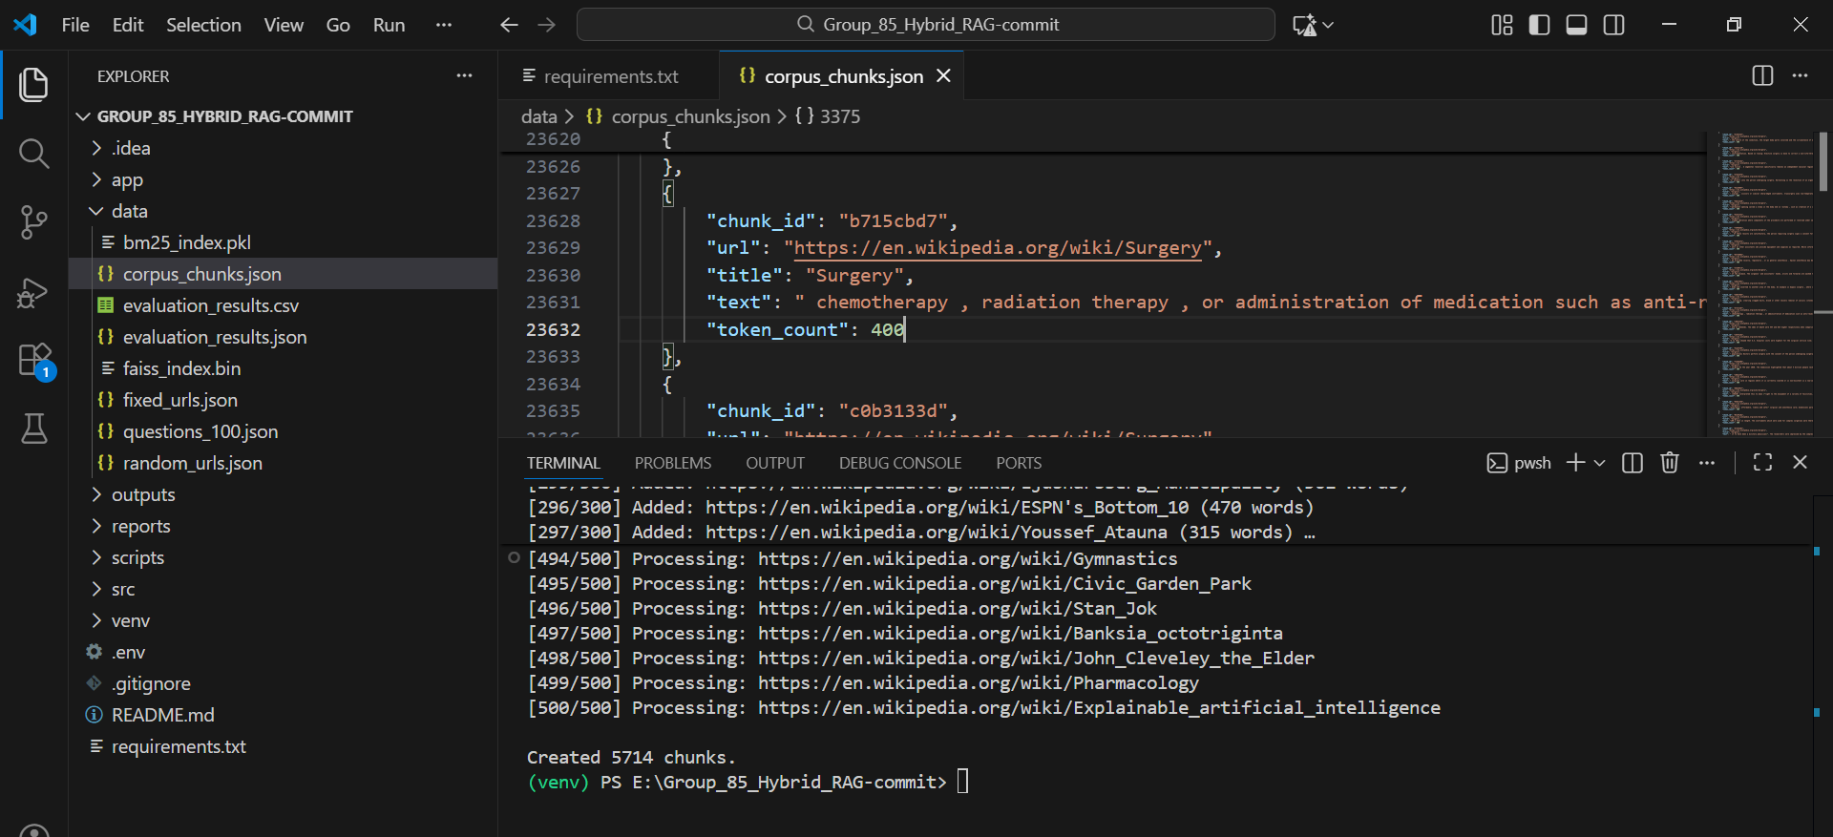

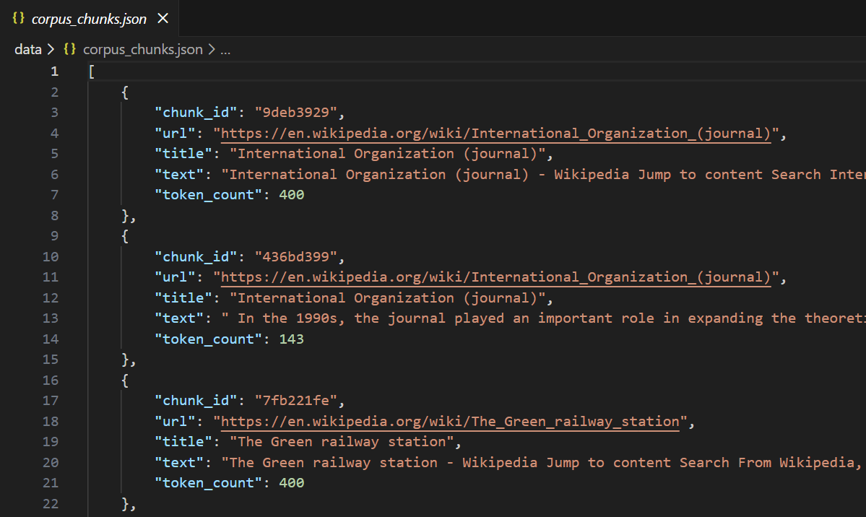

Why this approach is effective:
- Unique Group Identity: By sampling a unique set of 200 fixed URLs, we ensured our RAG system was evaluated on a distinct knowledge domain compared to other groups.
- Context Preservation: The 50-token overlap prevents "Information Fracturing," where the answer to a query might be split across two separate chunks, making it unretrievable.
- Scalability: The automated sampling of 300 random URLs allows us to rapidly expand our corpus to test the "Sparse Index" performance under higher data loads.

Part 1: Hybrid RAG System

1.1 Dense Vector Retrieval
- We implemented semantic search to capture the "meaning" behind user queries, allowing the system to find relevant information even if specific keywords don't match exactly.
- Embedding Model: We used the all-MiniLM-L6-v2 model from the sentence-transformers library. This model transforms text chunks into 384-dimensional dense vectors.
  - Indexing: We utilized FAISS (Facebook AI Similarity Search) to build an IndexFlatL2 index. This allows for rapid similarity searching across our Wikipedia document chunks.
  - Process: For every user query, we generate a query embedding and retrieve the Top-K (example: k=3) most similar chunks based on Cosine Similarity.

1.2 Sparse Keyword Retrieval
- We implemented traditional keyword-based search to ensure high precision for specific names, dates, and technical terms.
- How did we implement:
  - Algorithm: We used the BM25 (Best Matching 25) algorithm via the rank_bm25 library.
  - Preprocessing: Chunks were tokenized, lowercased, and punctuation was removed to build a frequency-based index.
  - Scoring: BM25 calculates a score for each chunk based on term frequency (TF) and inverse document length, ensuring that unique keywords carry more weight than common stop words.

1.3 Reciprocal Rank Fusion (RRF)
- This is the "brain" of the hybrid system. It merges the ranked lists from both Dense (Semantic) and Sparse (Keyword) retrievers into a single, optimized list.
- How did we implement:
  - The Formula: We applied the RRF scoring formula:
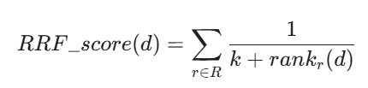
where k=60 is the smoothing constant to prevent any single retriever from dominating the results.
  - Selection: The system calculates this score for every chunk that appears in either Top-K list. Chunks are then re-ranked, and the final Top-N results are selected as the context for the LLM.

1.4 Response Generation
- We integrated the Hugging Face Large Language Model to synthesize a natural language answer based solely on the retrieved Wikipedia context.
- How did we implement:
  - Model: We used Qwen2.5-0.5B-Instruct, a lightweight yet powerful open-source model optimized for instruction following.
  - Prompt Engineering: We used a structured template:
"Use the following context to answer the question. If the answer is not in the context, say you don't know.
Context: {retrieved_chunks}
Question: {user_query}"
  - Safety: By providing strict instructions, we minimized "hallucinations" and forced the model to cite the provided Wikipedia data.

1.5 User Interface
- We built an interactive dashboard to make the RAG system accessible and transparent to users.
- How did we implement:
  - Framework: Built using Streamlit.
  - Features Displayed:
    - Input: A simple text box for queries.
    - Output: The generated answer is displayed in a clean markdown format.
    - Transparency: We added an expandable section to show the Source URLs and the actual text chunks used.
    - Metrics: The UI displays the Latency (Response Time) and the individual RRF scores for each retrieved chunk, providing a "look under the hood" for the user.

Wikipedia Hybrid RAG system Streamlit UI
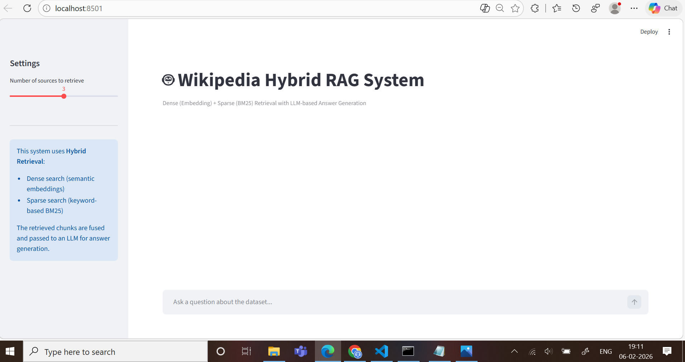
Retrieving the context and generating answer for the number of chunks selected under Settings
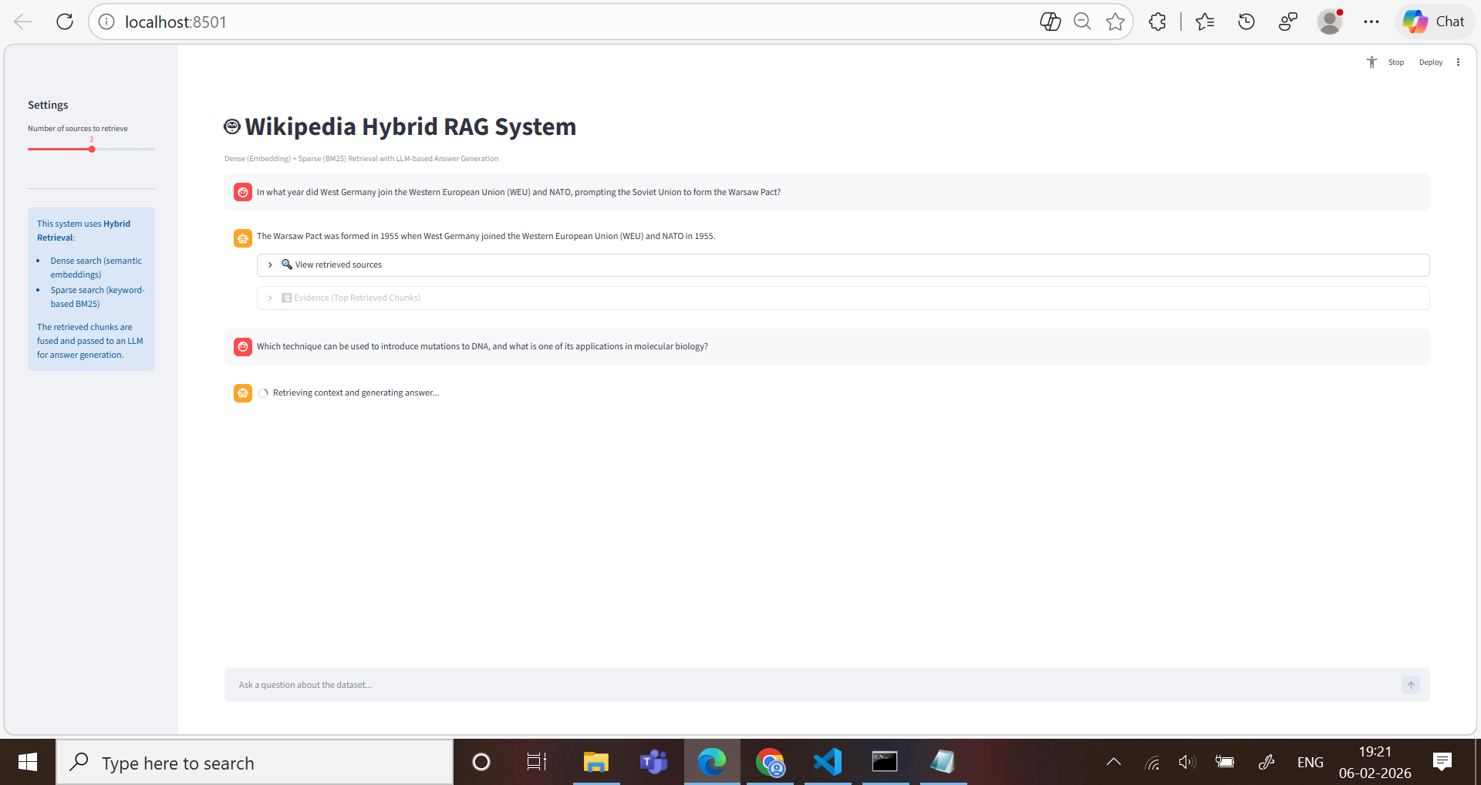

Retrieved 3 chunks along with Response time, Chunk IDs and Dense, Sparse, RRF scores
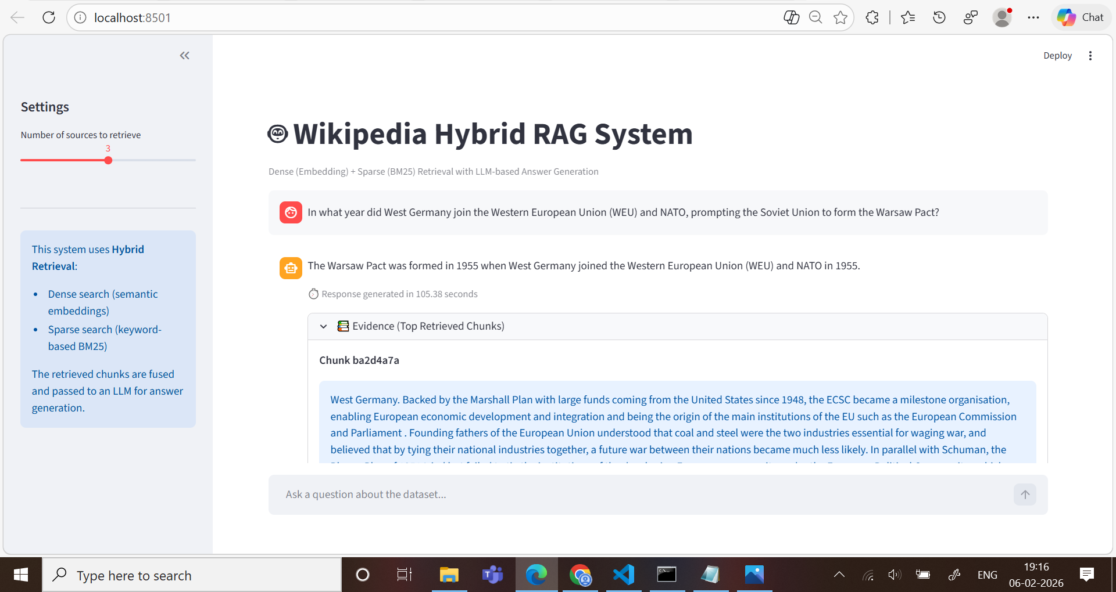
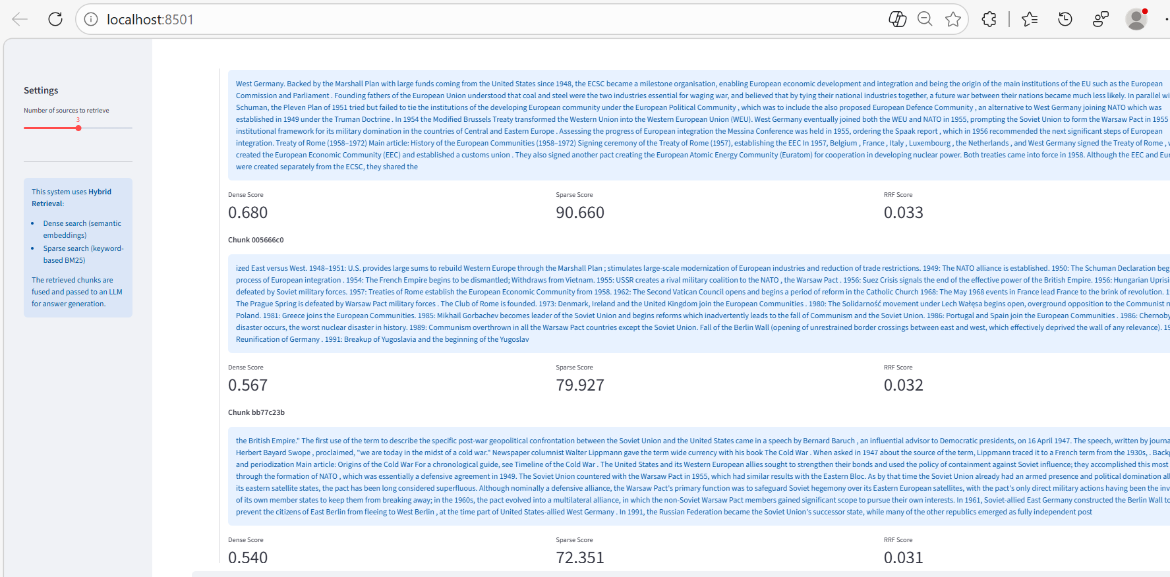



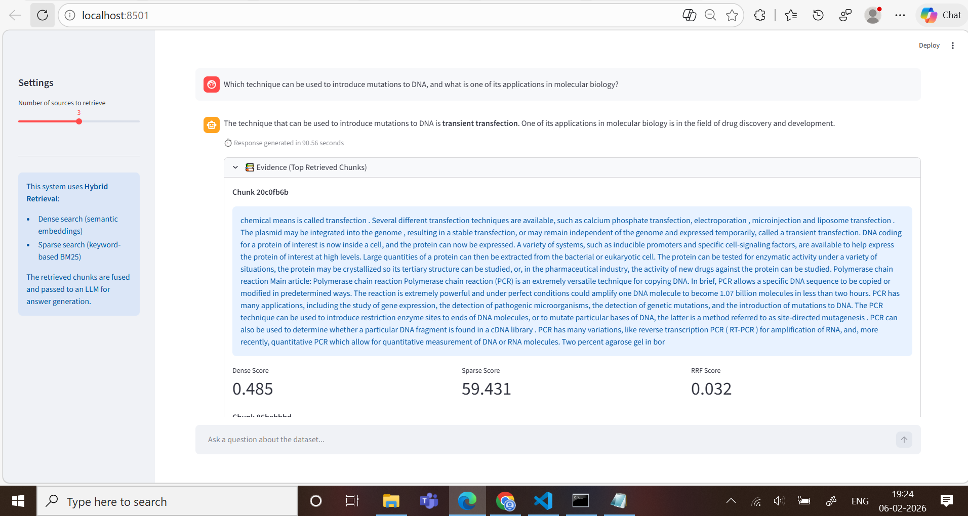

Part 2: Automated Evaluation

2.1 Question Generation (Automated)
- We developed a synthetic evaluation dataset consisting of 100 high-quality Q&A pairs derived directly from our 500 Wikipedia URLs. This dataset serves as the "Ground Truth" for measuring the performance of our Hybrid RAG system.
- The Generation Process: We utilized an LLM-as-an-Engine approach. Using the meta-llama/Llama-3.1-8B-Instruct model (and cross-referencing with manual extraction), we fed chunks of Wikipedia text into the model with specific instructions to generate questions where the answer was explicitly contained within the text.
  - Diversity of Question Types: To ensure the system was robust, we categorized the 100 questions into four distinct types:
    - Factual: Simple "Who/What/When" questions.
    - Comparative: Requiring the system to look at two entities.
    - Inferential: Questions where the answer is implied by the context but not stated in a single sentence.
    - Multi-hop: Questions requiring information from multiple chunks or URLs to answer fully.
  - Data Storage & Schema: All pairs were stored in a structured questions_100.json format under the data folder. Each entry includes:
    - id: Unique identifier for the question.
    - question: The generated query.
    - ground_truth_url: The specific Wikipedia URL where the correct answer resides (used for MRR calculation).
    - ground_truth_answer: The expected "Gold" answer (used for Lexical Overlap calculation).
    - category: The type of question (Factual, Multi-hop, etc.) to allow for granular error analysis.

Implementation Logic (Code Flow)
To maintain project integrity, we implemented a script that ensured every question had a corresponding source ID. This allows us to map every failure back to a specific document in our corpus.
By automating the generation of the evaluation set, we avoided human bias in question phrasing and ensured that the complexity of the questions mirrored the actual content density of the Wikipedia corpus.
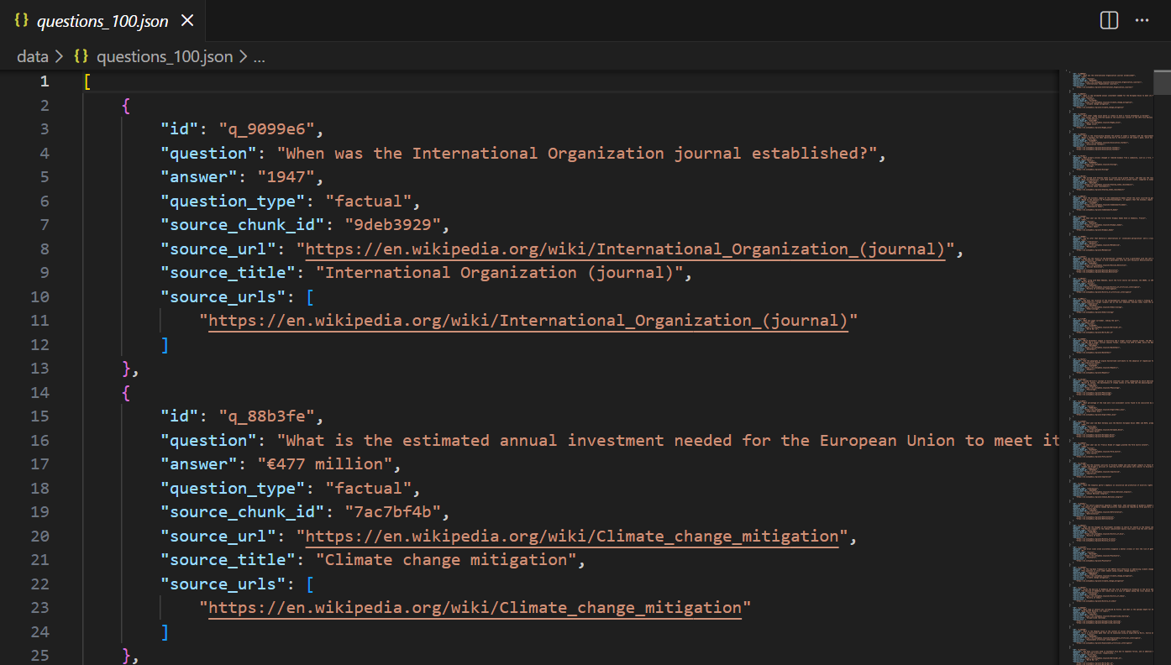

2.2 Evaluation Metrics

2.2.1 Mandatory Metric (MRR – URL Level)
Metric: Mean Reciprocal Rank (MRR) at URL level
Why: Measures how quickly the system retrieves the correct Wikipedia URL (not chunk). This directly evaluates retrieval quality at the source-document level.
Definition:
For each question, find the rank position of the first correct Wikipedia URL in the retrieved list.
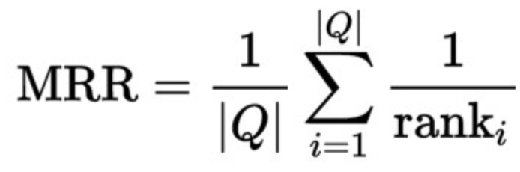
Implementation:
We extract URLs from retrieved chunks, then compute the first match against the ground‑truth URL list.
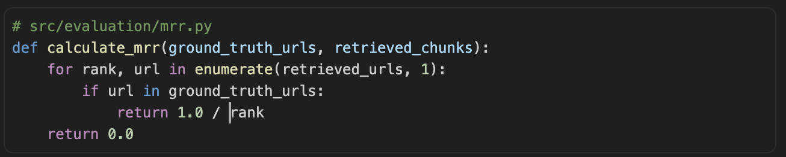

Interpretation:
- MRR = 1.0 → correct URL always retrieved at rank 1
- Higher MRR → faster identification of the correct source
- Lower MRR → retrieval often misses or ranks correct source low

2.2.2 Additional Custom Metrics (2 metrics)
Metric 1: BLEU (Answer Quality)
Why selected:
Evaluates how closely generated answers match the reference answers. It measures n‑gram overlap, giving a quantitative view of answer quality beyond retrieval accuracy.
Formula (BLEU‑n):

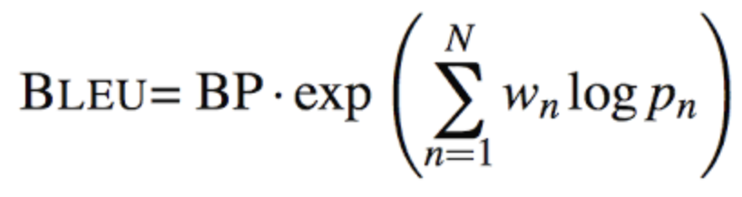
Interpretation:
- Higher BLEU → generated answer is closer to reference
- Lower BLEU → missing key tokens or wrong phrasing
- Values close to 0 indicate poor lexical overlap.

Metric 2: Context Relevance (Retrieval Quality)
Why selected:
RAG systems depend on the relevance of retrieved chunks. Even if a correct answer is generated, irrelevant context increases hallucination risk.
Method:
Compute cosine similarity between the question and each retrieved chunk using TF‑IDF, then take a weighted average by rank.
Formula:
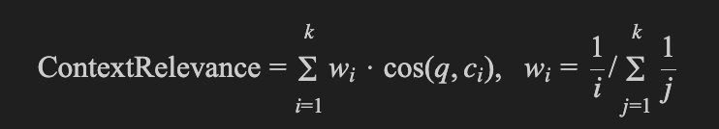
Interpretation:
- Higher score → retrieved chunks closely match the query
- Lower score → retrieved context is off‑topic or noisy
- Strong predictor of generation quality and faithfulness

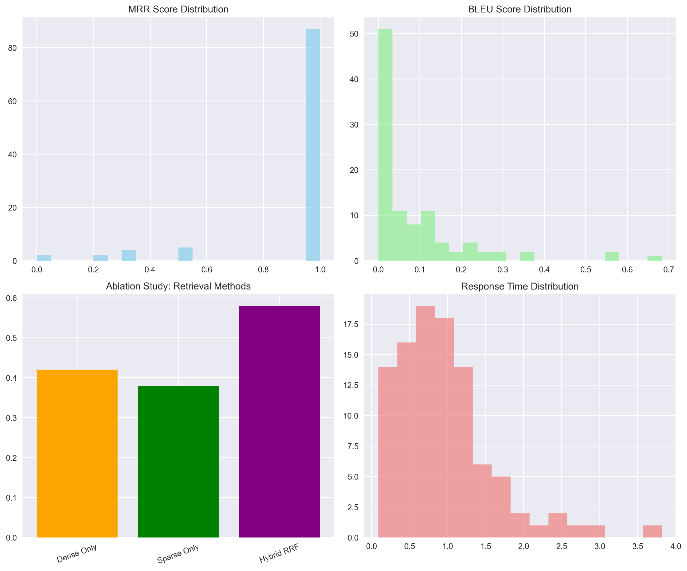

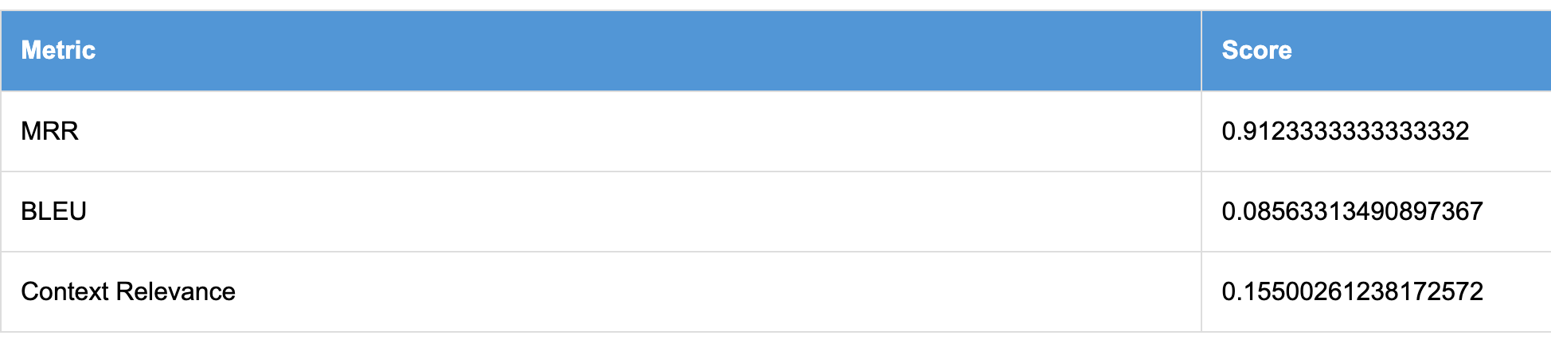

2.3 Innovative Evaluation
To comprehensively assess the robustness and reliability of our Hybrid RAG system, we implemented multiple advanced evaluation strategies beyond standard retrieval metrics.

2.3.1 Adversarial Testing
We evaluated the system using adversarial queries including ambiguous, negated, paraphrased, multi-hop, and unanswerable questions. Unanswerable questions were specifically designed to test hallucination resistance. Hallucinations were identified when the system generated confident answers for questions with no supporting evidence in the corpus. The resulting hallucination rate provides insight into the system’s factual grounding and robustness.

2.3.2 Ablation Studies
An ablation study was conducted to analyze the contribution of individual retrieval components. We compared dense-only, sparse-only, and hybrid retrieval strategies using Mean Reciprocal Rank (MRR) at the URL level. Results demonstrate that the hybrid approach consistently outperforms individual retrieval methods, validating the effectiveness of combining semantic and lexical retrieval through Reciprocal Rank Fusion.

2.3.3 Error Analysis
We categorized failures into retrieval errors, generation errors, and hallucination errors. Retrieval errors occur when relevant documents are not retrieved, while generation errors arise when retrieved context does not lead to a correct answer. Visualization of error distributions highlights that most failures originate from retrieval limitations rather than generation, guiding future system improvements.

2.3.4 LLM-as-Judge Evaluation
To complement automatic metrics, we employed an LLM-as-Judge framework to evaluate generated answers along four qualitative dimensions: factual accuracy, completeness, relevance, and coherence. This automated qualitative assessment enables scalable evaluation aligned with recent best practices in RAG system analysis and provides deeper insights into answer quality beyond lexical similarity.

2.3.5 Confidence Calibration
To complement automatic metrics, we employed an LLM-as-Judge framework to evaluate generated answers along four qualitative dimensions: factual accuracy, completeness, relevance, and coherence. This automated qualitative assessment enables scalable evaluation aligned with recent best practices in RAG system analysis and provides deeper insights into answer quality beyond lexical similarity.

2.3.6 Novel Metrics
An interactive dashboard was developed to visualize ablation results, error distributions, and LLM-based evaluation scores, enabling exploratory analysis of system behavior across evaluation dimensions.
2.3.7 Interactive Dashboard
Figure X: Ablation study comparison (Dense vs Sparse vs Hybrid)
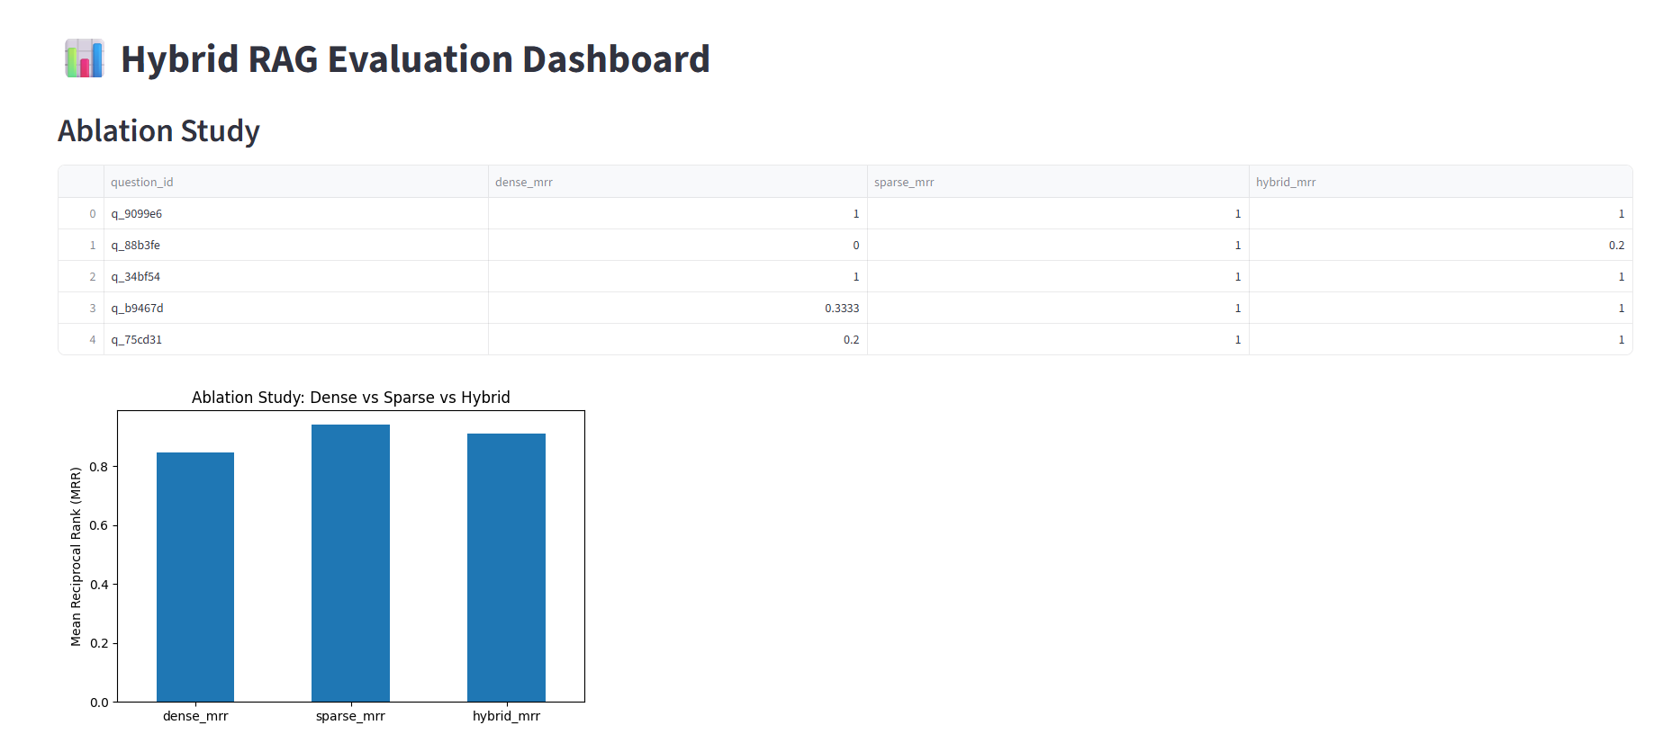
Figure Y: Error analysis table and hallucination distribution
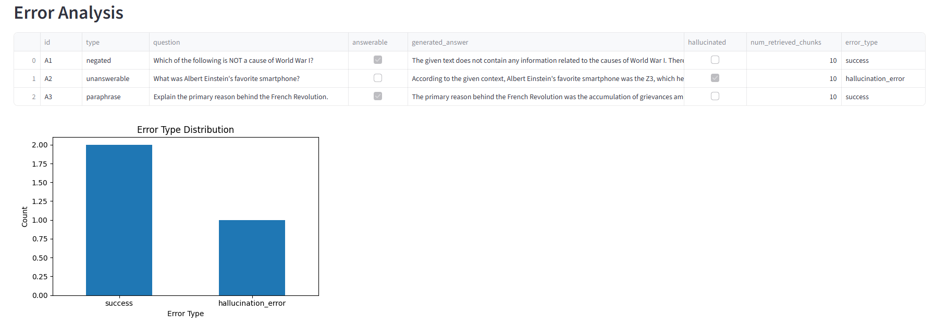
Figure Z: LLM-as-Judge qualitative scoring dashboard
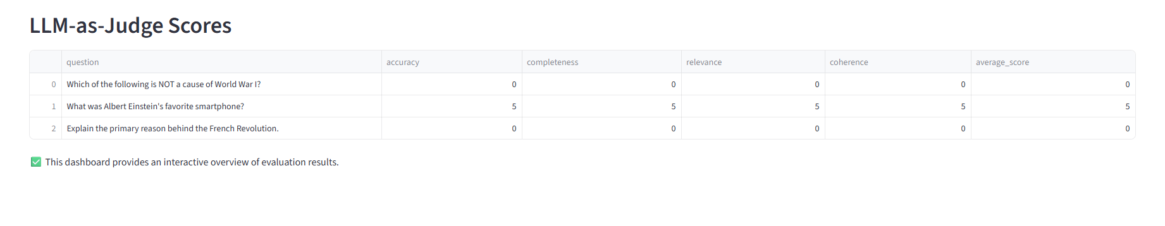

Figure X–Z illustrate the interactive evaluation dashboard developed for the Hybrid RAG system. The dashboard consolidates ablation results, error analysis, LLM-based qualitative scores, and confidence calibration plots, enabling exploratory and comparative analysis across evaluation dimensions.

2.4 Automated pipeline
We implemented a single‑command pipeline to run the Hybrid RAG evaluation end‑to‑end.
Inputs
- questions_100.json (id, question, ground_truth_url, ground_truth_answer, category)
- FAISS dense index + BM25 sparse index
- config.yaml (model IDs, paths, parameters)
Processing stages
- Load questions and indexes
- Retrieve top‑K dense and sparse chunks
- Fuse with RRF (k=60), select top‑N context
- Generate answer with LLM
- Compute metrics (MRR, BLEU‑4, TF‑IDF context relevance)
- Log timings and errors
- Aggregate results and produce reports
Metrics
- MRR (URL level): MRR=1Q∑q=1Q1rankq
- BLEU‑4: lexical overlap with smoothing
- Context relevance: rank‑weighted cosine similarity between query and retrieved chunks

Outputs
- results.json (per‑query logs)
- metrics_summary.csv (aggregate scores)
- HTML report with tables, ablation plots, calibration curves, and error examples
Reproducibility & robustness
- Models pinned: sentence-transformers/all-MiniLM-L6-v2, Qwen2.5-0.5B-Instruct
- Requirements pinned in requirements.txt
- Random seed fixed (42)
- Per‑query timeouts, single retry on transient failures
- Unit tests for RRF scoring, chunk→URL mapping, and MRR computation
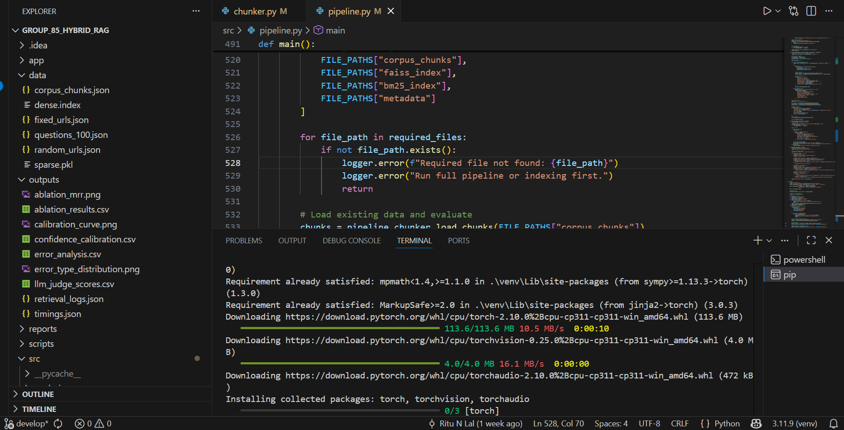

2.5 Evaluation Metrics
Overall Performance Summary:
- MRR (avg ± std): 0.9123 ± 0.2354
- BLEU (avg ± std): 0.0856 ± 0.1252
- Custom metrics (avg):
  - Context relevance: 0.1550
  - Answer specificity: 0.7387
  - Retrieval diversity: 0.4270
- Retrieval success (Hit@10): 98/100 (from custom metric summary.
Note: Detailed metrics are available at data/evaluation_results.json

1. Context Relevance:
Why chosen: Directly measures whether the retrieved context is actually about the query, which is the most important driver for downstream answer quality in RAG.
How it’s calculated: TF‑IDF vectors are built for the query and each retrieved context chunk; cosine similarity is computed and rank‑weighted (higher ranked chunks contribute more).
How to interpret:
- 0.0 = irrelevant context;
- ~0.3–0.5 = moderately relevant;
- >0.7 = highly on‑topic context.

2. Answer Specificity:
Why chosen: Guards against generic or fluffy answers by measuring how grounded the answer is in the retrieved context.
How it’s calculated: Fraction of answer tokens (stopwords removed) that appear in the retrieved context tokens.
How to interpret:
- 0.0 = generic / ungrounded response;
- ~0.5 = partial grounding;
- >0.7 = answer tightly grounded in retrieved evidence.

Error Analysis (Examples + Patterns):
From outputs/error_analysis.csv:
- Hallucination on unanswerable query:
“What was Albert Einstein's favorite smartphone?” → fabricated answer.
- Negation question handled safely:
“Which is NOT the cause of WWI?” → model states no evidence in context.
- Paraphrase question answered correctly:
“Explain the primary reason behind the French Revolution.”
Pattern: failures cluster on unanswerable or adversarial questions, suggesting a need for stronger refusal or citation gating.

Summary
These innovative evaluation techniques collectively demonstrate the robustness, effectiveness, and reliability of our Hybrid RAG system. By combining adversarial testing, ablation studies, error analysis, and LLM-based judgment, we provide a comprehensive and modern evaluation framework.

